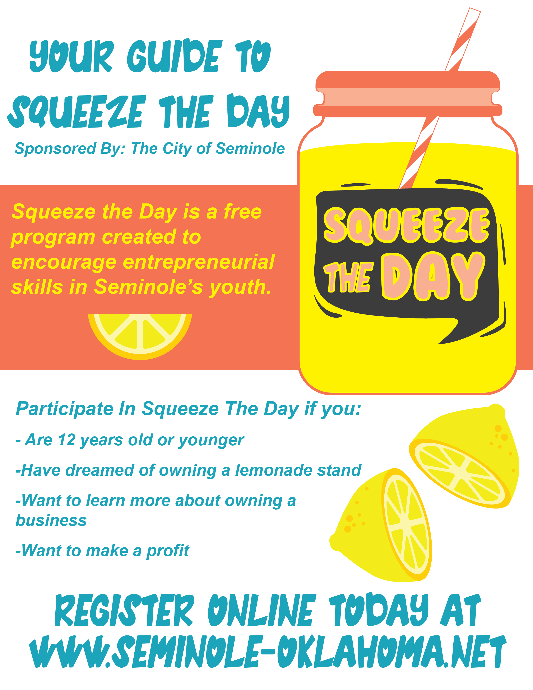
A letter to Parents and Guardians

Thank you for your interest in “Squeeze the Day”. We are so excited to present this new free program to Seminole residents, and hope that you and your family will participate. We have made the dates of “Squeeze the Day” the same time as “City Wide Garage Sale”. Garage sale permit fees are waived during this time.

We encourage parents and guardians to work with their children on this project, and make this event into your own. We understand some participants may go all out and invite the entire town to their lemonade stand while others are happy with a small family and friend gathering to enjoy lemonade on the porch. We want both types of participation!

We have three goals for this program:
- Encourage entrepreneurship among Seminole youth.
- Give youth a project to work on during the summer.
- Teach youth the importance of financial goals.

We created 3 contests for “Squeeze The Day”:
- Best Lemonade in Seminole
- Best Stand in Seminole
- Entrepreneur of Seminole
More details on each of these contests are given on pages 10 and 11 in this guide.

We have created this guide to help you and your children build your lemonade stand business. To enter the “Entrepreneur of Seminole” contest the guide must be completed, but the guide is optional if your team is not entering “Entrepreneur of Seminole”.

We want “Squeeze the Day” to be a program that you and your family enjoy so we encourage you to make your lemonade stand your own unique design. If you have questions or concerns about “Squeeze The Day” please feel free to call Briana Wymore at the community development office during office hours at
405-382-4330 ext 113 or email Briana@Seminole-Oklahoma.net.

Sincerely,
City of Seminole
Your Checklist
- Make a business plan.
Use our business plan guide to write a business plan for your lemonade stand.

- Complete a permit application.
The last page of this guide is the permit application that allows you to get your free permit at the community development office. Don’t forget a letter from the property owner.

- Pick up your free permit.
Turn in your permit application (page 9) to the community development office located in the municipal building.

- Fill out the online registration.
Visit our website to register your lemonade stand online. When you do this your stand will be pinned to a map that the public can view.

- Market your stand.
Use your marketing skills to get the word out that you are opening your lemonade stand.

- Open your stand and make a profit.
Open your lemonade stand and let your hard work pay off.

- Don’t forget about our local contests.
Find information about our different contests on our website. You can enter to have the “Best Lemonade in Seminole”, the “Best Stand in Seminole”, and be the “Entrepreneur of Seminole”.

Definitions
Entrepreneur - a person who organizes and operates a business or businesses, taking on greater than normal financial risks in order to do so.

Business Plan – a written document that describes an idea for a product or service and how it will make money. It includes your marketing plan as well as estimates for revenue, expenses, and how to make a profit.

Marketing – actions taken to promote products, services, or businesses like flyers, bulletins, ads in a newspaper, or ads on social media.

Profit – how much money is made.

The City of Seminole – the local government that plans rules, regulations, and other operations within the city limits of Seminole, Oklahoma.

Permit – an official document from The City of Seminole or other organization that allows someone to do something specific.

Squeeze The Day – an event created by the City of Seminole to promote entrepreneurial skills with Seminole youth.

do I really need a business plan?
A business plan is like a roadmap. It allows you to plan out the various aspects of your business on paper, and keeps you from making unnecessary mistakes later. It helps an entrepreneur think about the costs associated with starting a business and show investors that you are serious about your idea.

This business plan is specifically designed to help you be successful at “Squeeze the Day”. It will take you through branding your stand, marketing, creating a menu, finances, and completing a permit application.

If you have questions at any time, please contact Briana Wymore during office hours, 405-382-4330 ext 113 or by email at Briana@Seminole-Oklahoma.net.
Brand Your Stand

What is your lemonade stand’s name?
Create a name that is easy to say and remember for marketing purposes,

_____________________________________________________________________

How is your stand unique from others?
Make your stand unique by selling something not offered by other stands or maybe your stand has a great location that offers an inviting space. Create something that is yours and yours only so people will want to see it.

_____________________________________________________________________

What is on your menu?
Lemonade stands often sell more than lemonade. Iced tea, homemade baked goods, and candy is often on the menu of lemonade stands.

_____________________________________________________________________

Where is your stand located?
Location plays a big role in selling products. Most businesses prefer a place with high traffic so they can be seen. Squeeze The Day is on the same day as the “City Wide Garage Sale” on June 3rd-5th 2021. We advise you to find someone inside city-limits to host a garage sale and your lemonade stand. When searching remind property owners that garage sale permit fees are waived!

_____________________________________________________________________

Do you have the property owner’s permission?
To receive a permit for your lemonade stand, you need a signed letter of approval from the property owner of your stand’s location. We have included a letter for you to use on page 9 of this guide. Don’t worry about the permit fees. Participating in “Squeeze the Day” is all free!

_____________________________________________________________________

Marketing
Please tag @CityofSeminole and use #SqueezeSeminole for all social media posts.

What is your lemonade stand’s name?
Create a name that is easy to say and remember for marketing purposes,

_____________________________________________________________________

Who will be your customers?
Different businesses market to different types of people. For example, a toy company markets to kids and not adults. Will you focus on certain age group or type of person?

_____________________________________________________________________

How will you get the word out about your stand?
Spreading the word has no limits. Emails, flyers, social media, newspaper ads, and signs are all used when marketing a new product.

_____________________________________________________________________

Draw a picture you can use on a flyer to market your lemonade stand.
Consider writing the dates and hours your open along with the address of your set up.
Finances
What do you need to start your lemonade stand?
Do you have a table to set everything out? Will you make decorations? What supplies do you need? Some materials may be donated to you while others you might have to purchase. We made a chart for you to list out your supplies and costs to figure start up costs. Not all items may be listed. You may add and take away items as needed.

ITEM | PRICE
Table/Lemonade Stand
Decorations
Pitcher
Lemons
Sugar
Cups
Total Cost

Where will you get the money to cover start up costs?
Family members may donate or let you borrow money. A business may sponsor you. The hardest part is asking for money, but the worst thing that can happen is that they say no. Keep asking and someone is bound to say yes.

_____________________________________________________________________

What is the cost of each serving of lemonade (cost per cup)?
Cost per cup = (Total Expenses of Lemons, Sugar, Cup) / # of products to be made
Example: ($3.50 lemons + $1.15 sugar + $.10 cup) / 48 eight ounce cups = $.10 per cup

_____________________________________________________________________

How much will your lemonade cost?
Consider comparing prices with other lemonade stands to keep your price competitive. Make sure your price is above the cost per serving so you make a profit.

_____________________________________________________________________

What will be your profit off each lemonade cup?
Profit is how much you make after you subtract your expenses.
Example: $.75 - $.10 = $.65
If a person sells 48 cups of lemonade at $.75 per cup, they would profit $31.00 total!

_____________________________________________________________________

Use the table, below to show your profit for each item on the menu.
Like lemonade, keep your prices competitive, and make sure your price is above the cost per serving.

ITEM | COST PER SERVING | PRICE | PROFIT PER ITEM
(Example) 8 oz Lemonade | $.10 | $.75 | $.65

What will you do with your profits?
People make financial goals to decide how to use their hard-earned money. Your financial goals may look like saving money for college or a particular item, donating money to a special cause, or spending it on a fun trip. Many people budget their money into different categories: spending, saving, and investing. Make a financial plan for yourself so you can handle money wisely.

_____________________________________________________________________

Permit Application
Complete this page and take to the community development office during office hours or scan it and email it to Briana@Seminole-Oklahoma.net to receive your free permit.

First and Last Name

_____________________________________________________________________

Business Name

_____________________________________________________________________

Email

_____________________________________________________________________

Phone Number

_____________________________________________________________________

Location Address

_____________________________________________________________________

Permission from the Property Owner
Dear City of Seminole,

______________________ has my permission to set up a lemonade stand for “Squeeze the Day”.
Lemonade Stand’s Name

Sincerely,

______________________
Property Owner’s Name
Entrepreneur of Seminole
Please do the following checklist to enter “Entrepreneur of Seminole”.

CHECKLIST
- A completed guide (pages 5-8)
- A completed feedback sheet (page 10)
- A picture of you with your lemonade stand
- Any marketing material you used

Completed applications can be emailed to Briana@Seminole-Oklahoma.net or brought in person to the community development office during office hours.

What did you enjoy about running a lemonade stand?

_____________________________________________________________________

What marketing strategies did you use?

_____________________________________________________________________

What would you do different next time?

_____________________________________________________________________

What kind of obstacles did you overcome and how did you do so?

_____________________________________________________________________

What was your total profit at the end of the day?

_____________________________________________________________________

Best Lemonade of Seminole
Please do the following to enter “Best Lemonade of Seminole”.

To participate in this contest you must:
- Complete the online registry form.
- Get a permit from community development (page 9).
- Be open sometime from 8 am – 5 pm on June 4th.

The judges will come by your stand on Friday, on June 4th to taste test your lemonade.

Winners will be announced by Friday, June 11th.

Best Stand of Seminole
Please do the following to enter “Best Stand of Seminole”.

To participate in this contest you must:
- Complete the online registry form.
- Get a permit from community development (page 9).
- Have any branding or marketing materials ready to give or show to judges.
- Be open sometime from 8 am – 5 pm on June 4th.

The judges will come by your stand on Friday, on June 4th to see your stand.

Winners will be announced by Friday, June 11th.

